Option D, New construction example, uncertainty quantification.

OpenStudio is free and open source. Tools exist to make site specific OpenStudio model. For this example, the Prototype Building measure (<https://github.com/NREL/OpenStudio-Prototype-Buildings>) will be used to create the building model so the user can reproduce the results here if desired.

The model used is a Medium Office, 90.1-2010 vintage in climate zone ASHRAE 169-2006-3C.

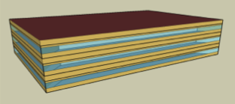

The sensitivity analysis is done using the OpenStudio Analysis Spreadsheet (<https://github.com/NREL/OpenStudio-analysis-spreadsheet>) and the cloud computing capabilities of OpenStudio Server (<https://github.com/NREL/OpenStudio-server>).

Use two different methods, Latin Hypercube Sampling (LHS) and the Morris Method. The variables of interest for this example are the Window to Wall Ratio (WWR), Lighting Power Density (LPD) and the Space Infiltration. All of these variables are changed using OpenStudio Measures.

**Input Variable ranges and distributions –** *(have a distribution for each input variable)*

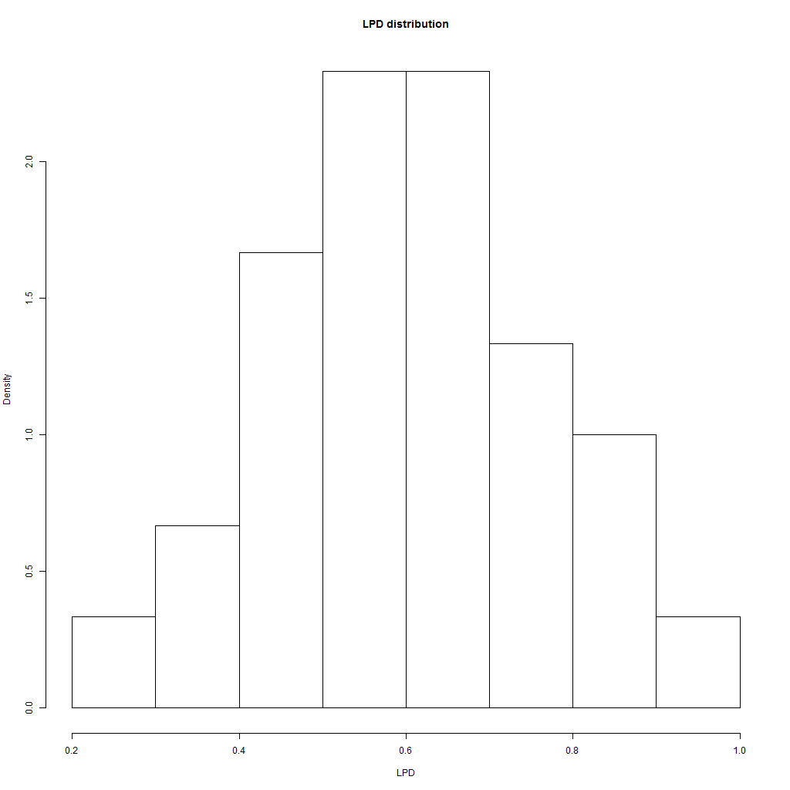

LPD

**LHS one at a time method**

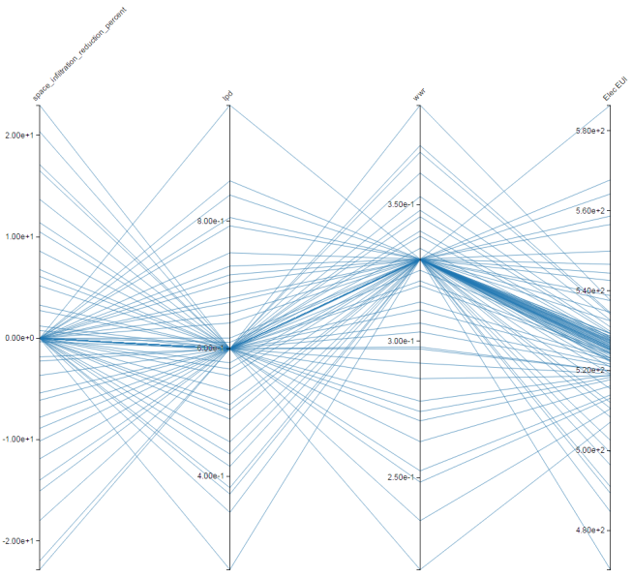

All Variables

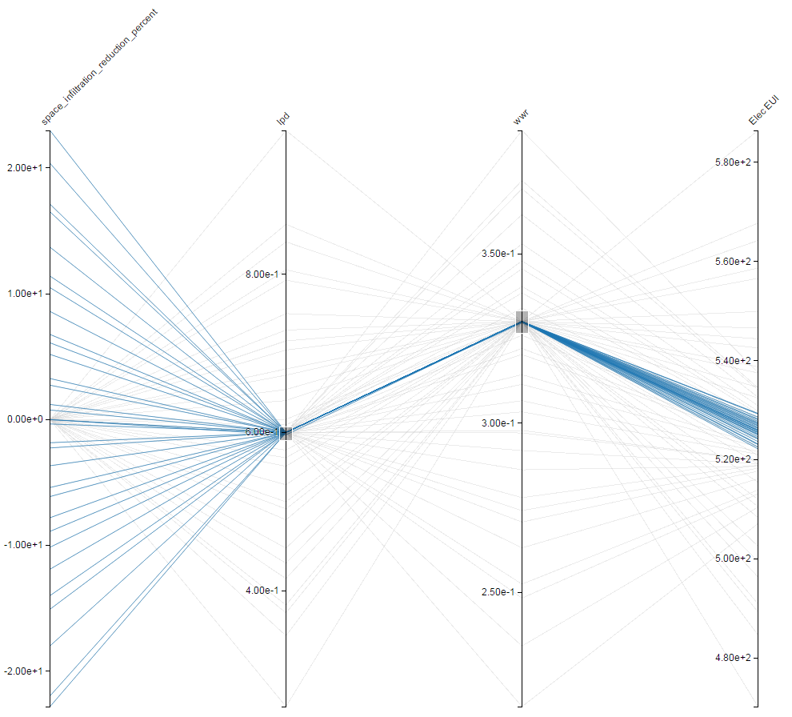

Space Infiltration % change – Small variation

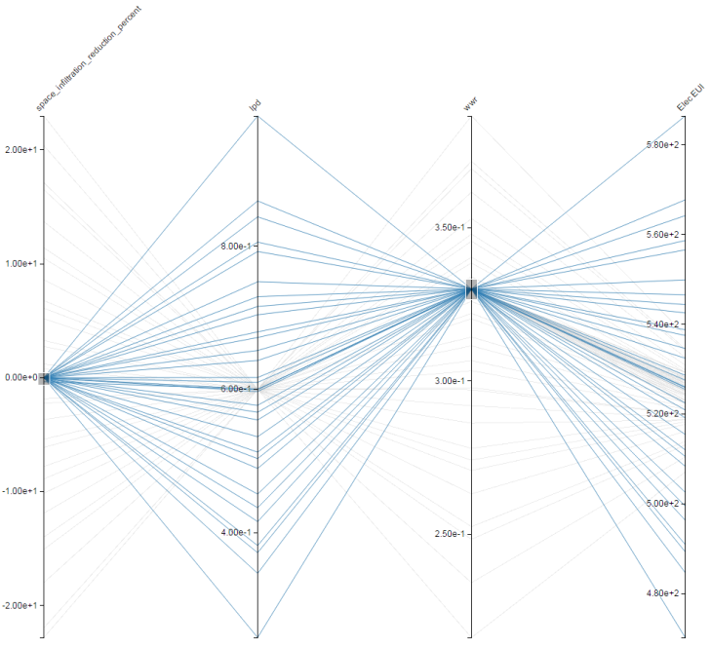

Lighting Power Dencity – large variation

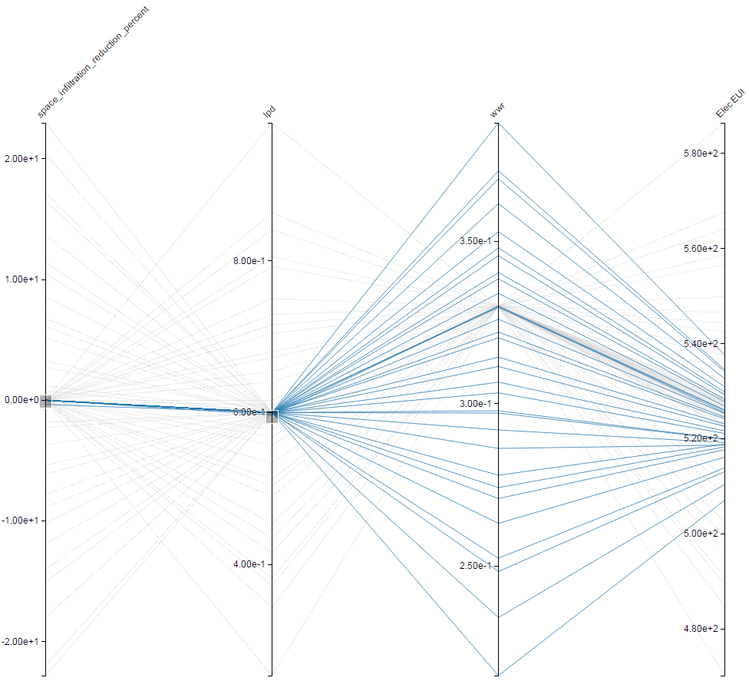

Window to Wall Ratio

**Morris Method**

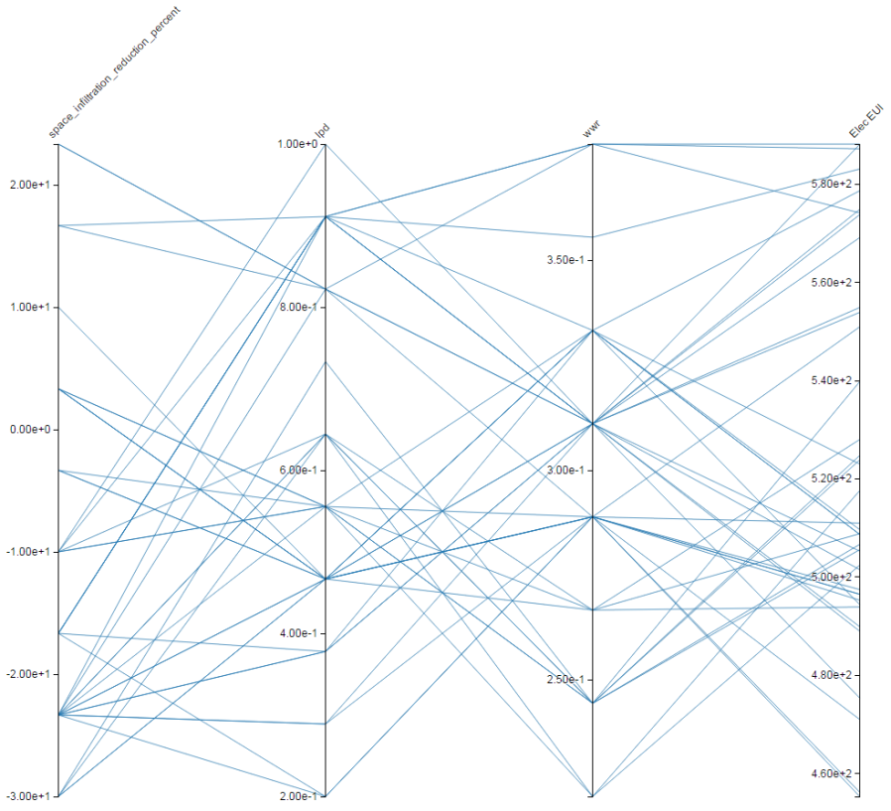

Sampling pattern for Morris Method

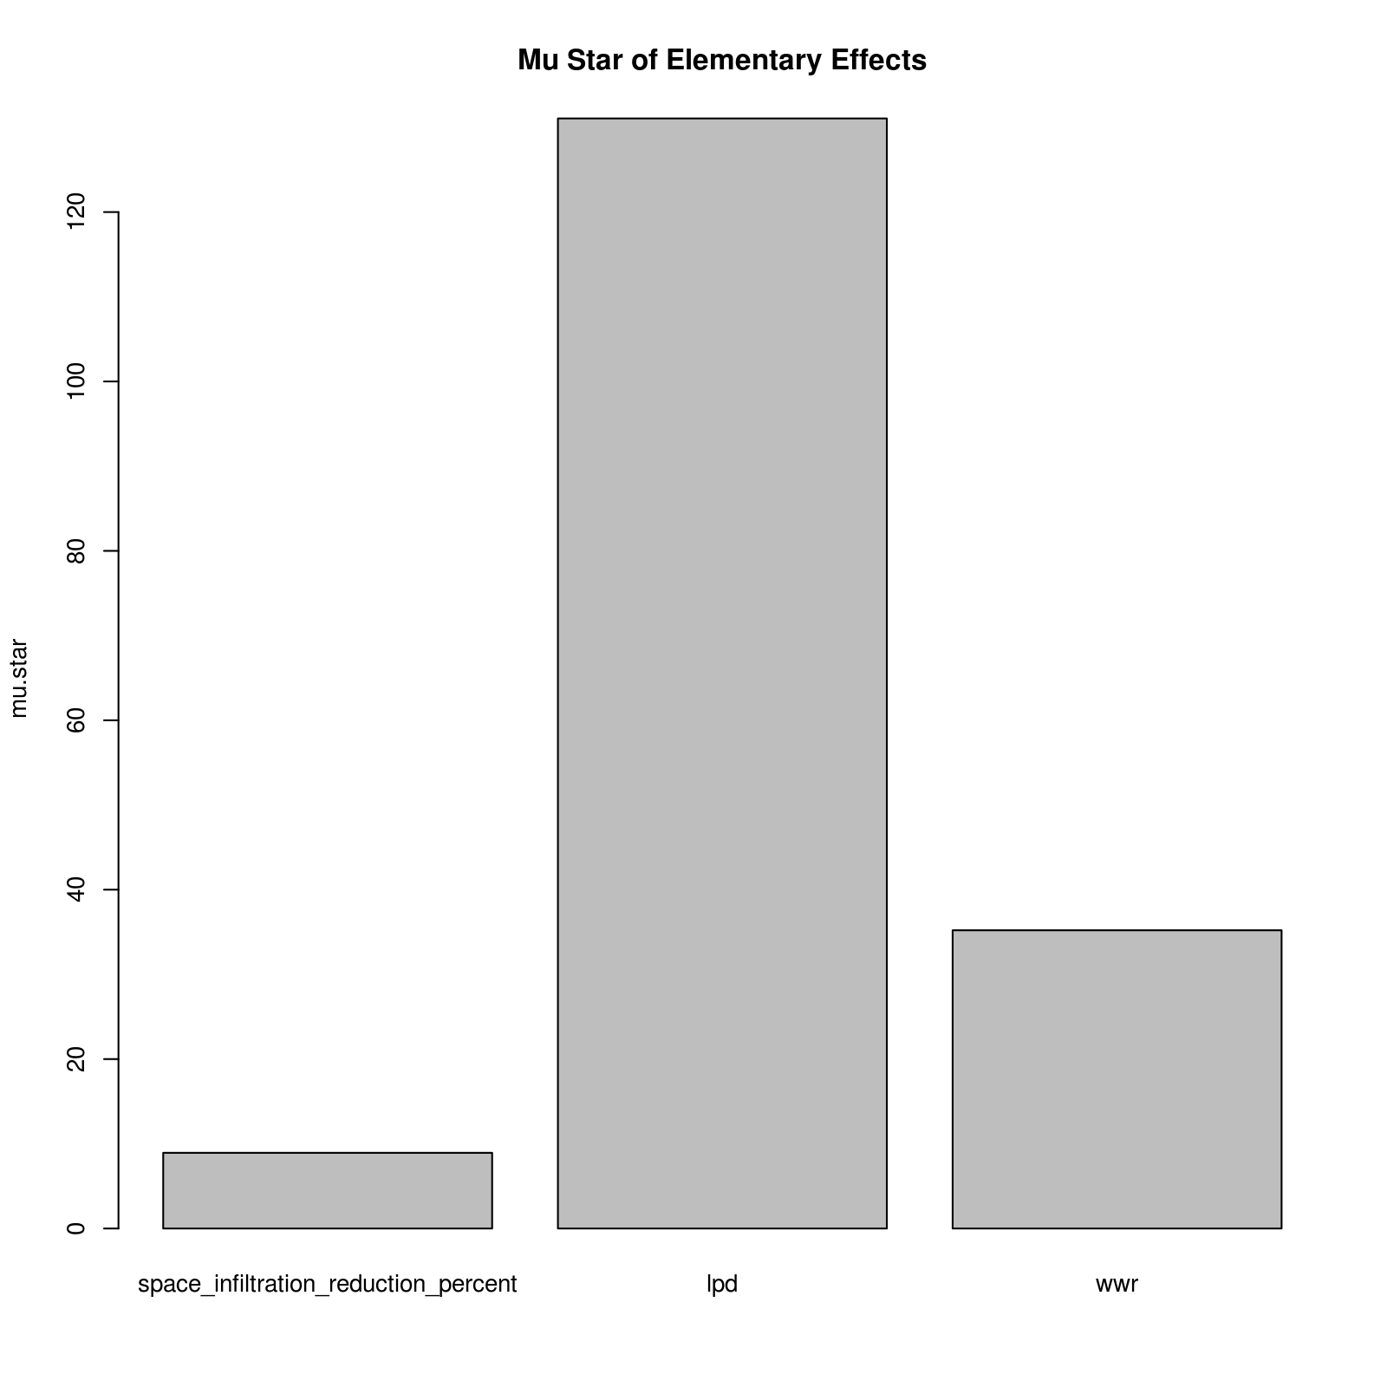

Average value of Elementary Effects from Morris Method

**LHS with all variables.** Use linear regression to estimate sensitivity of variables. Do grid refinement and see if answers converge (or stay consistent)

*(Summarize the below in a table format)*

